# **Light Monitoring with Bolt IoT**

* Post author
* By [harshtg9999](https://projectsubmission.boltiot.com/author/harshtg9999/)
* Post date
* [November 23, 2022](https://projectsubmission.boltiot.com/?p=19198)

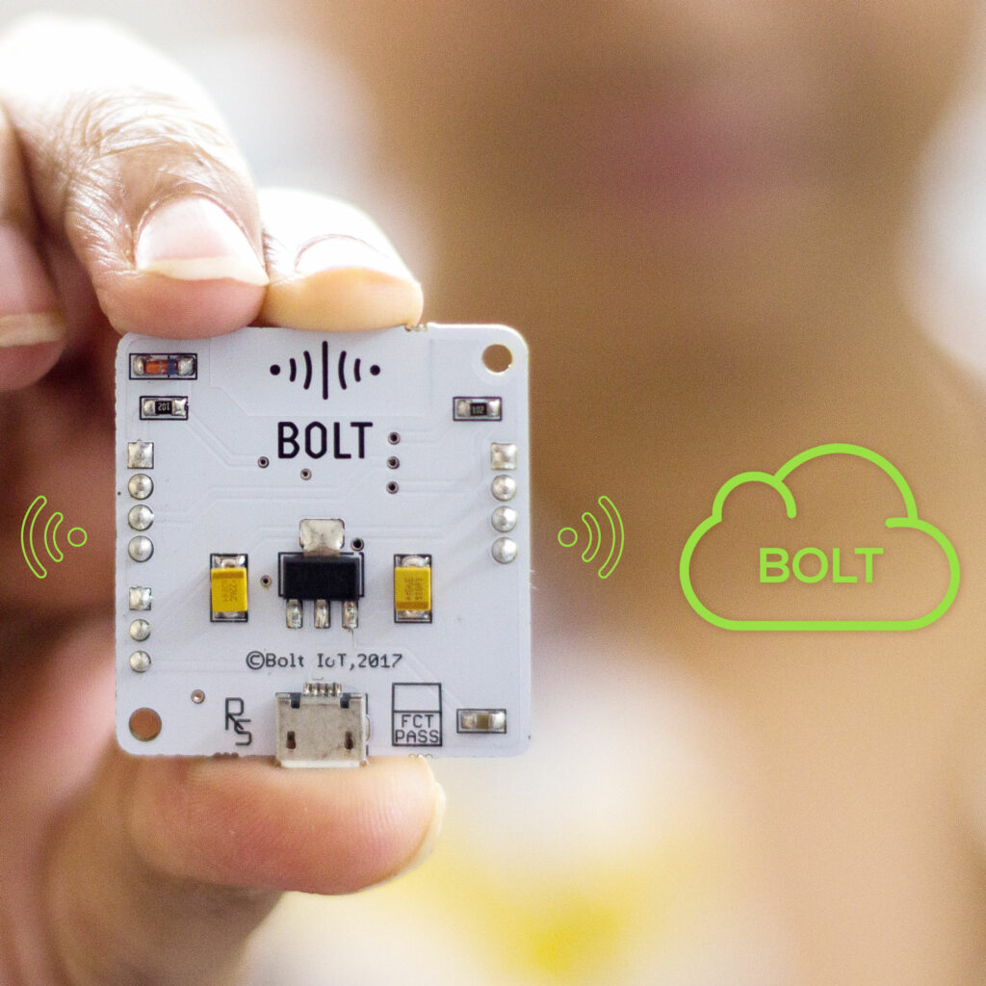

Light is a very basic need in our daily lives, but sometimes inappropriate intensity of light directly or indirectly affects us and the environment as well. Eye and Headaches are very common consequence of adverse light intensity. So there is a need to monitor the light intensity in order to get the most value of it.

## 

## **Things used in this project**

### **Hardware components**

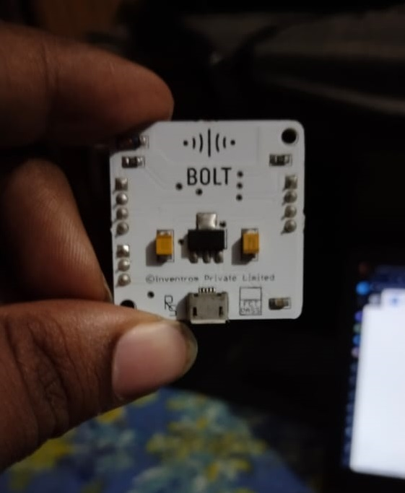

A Bolt Module

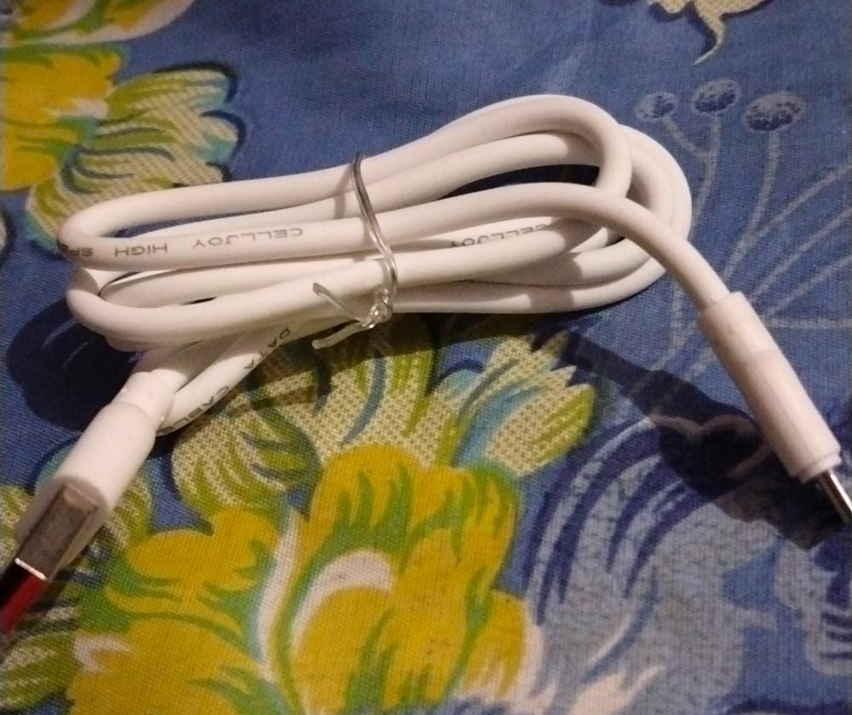A Micro USB Cable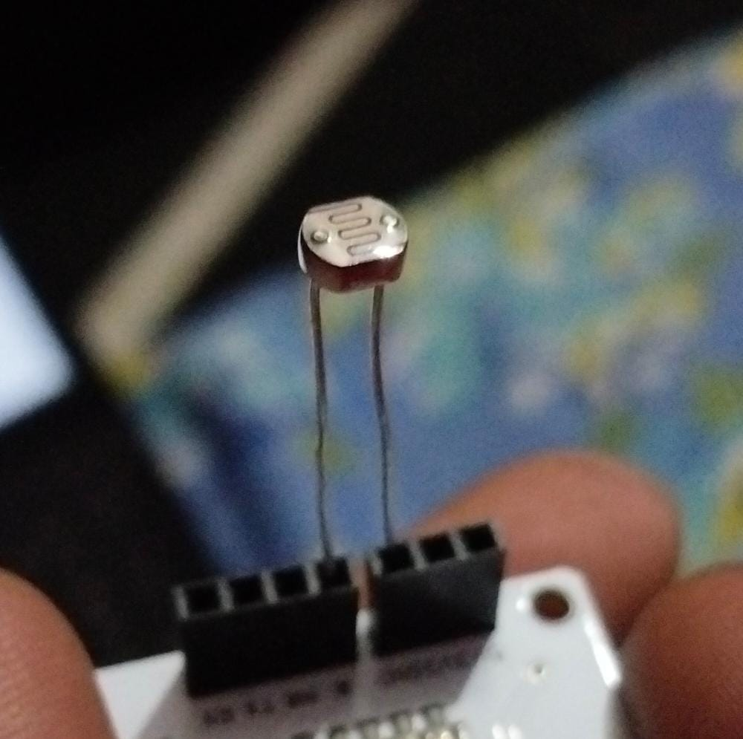1x LDR (Light Dependent resistor)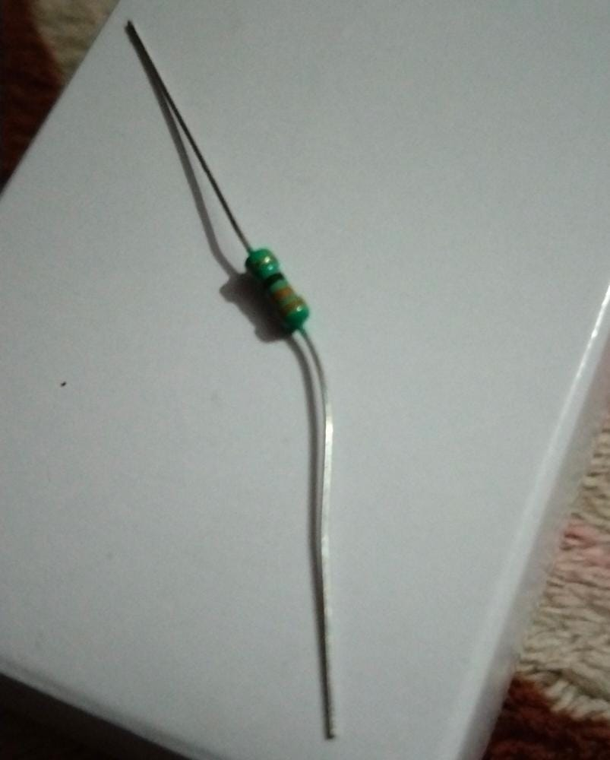1x 10k ohm resistor.

## 

## 

## 

## **Methodology**

The methodology of this system can be understood by the following Flow Chart:

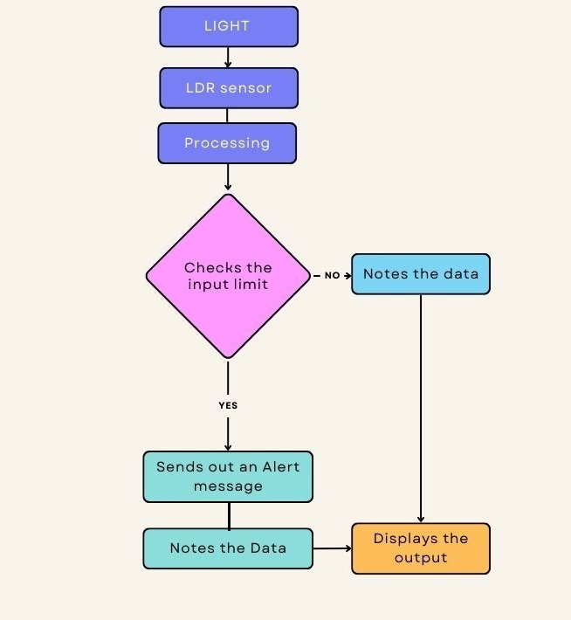

### 

### 

### 

### **Software, Apps and Online services**

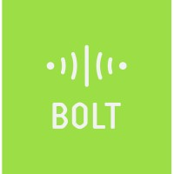

Service used – Bolt IoT

Link- www.boltiot.com

## **Hardware Setup**

Here are the steps for making the hardware connections:

Step 1: Insert one lead of the LDR into the Bolt Module’s 3v3 Pin.

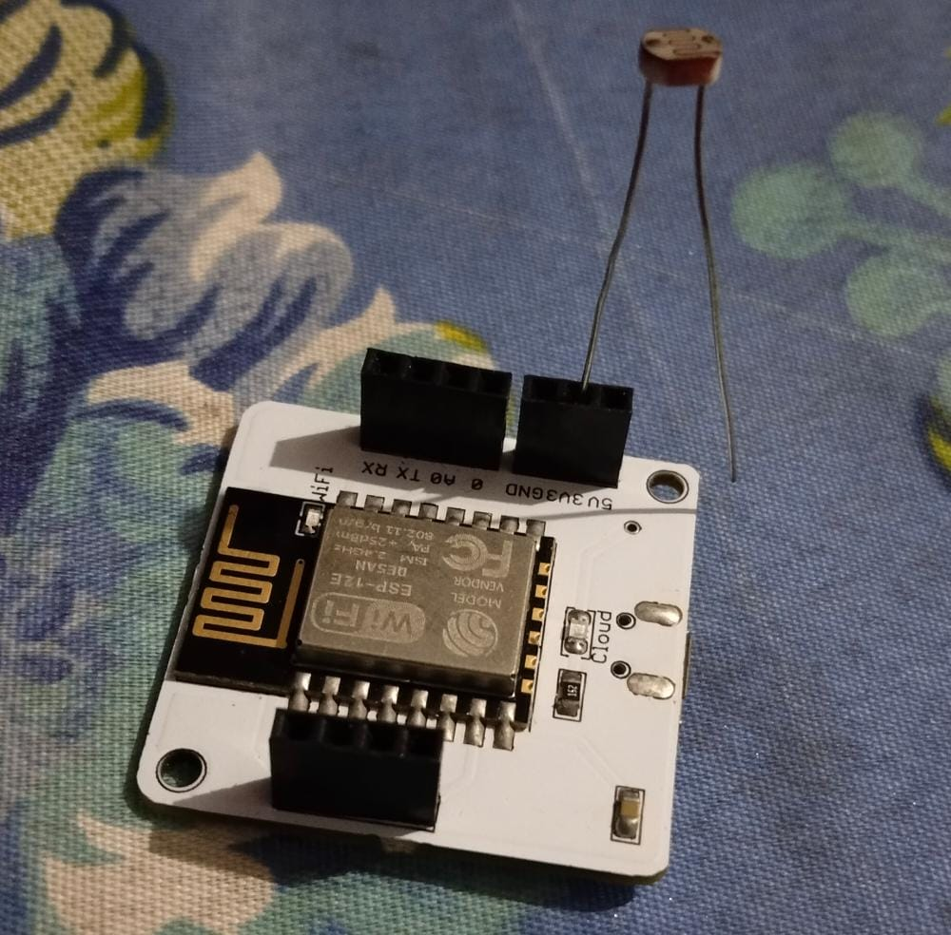

Step 2: Insert other lead of the LDR into the A0 pin.

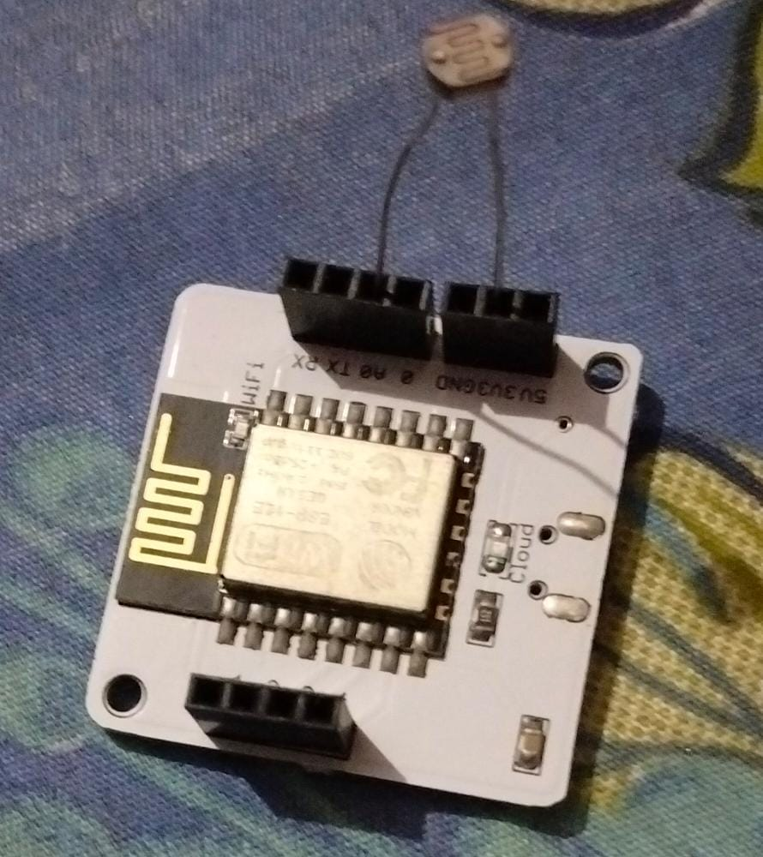

Step 3: Insert one leg of the 10k Ohm resistor into the GND pin.

Step 4: Insert the other leg of the resistor also into the A0 pin.

After succession of these steps, the final circuit should look like this:

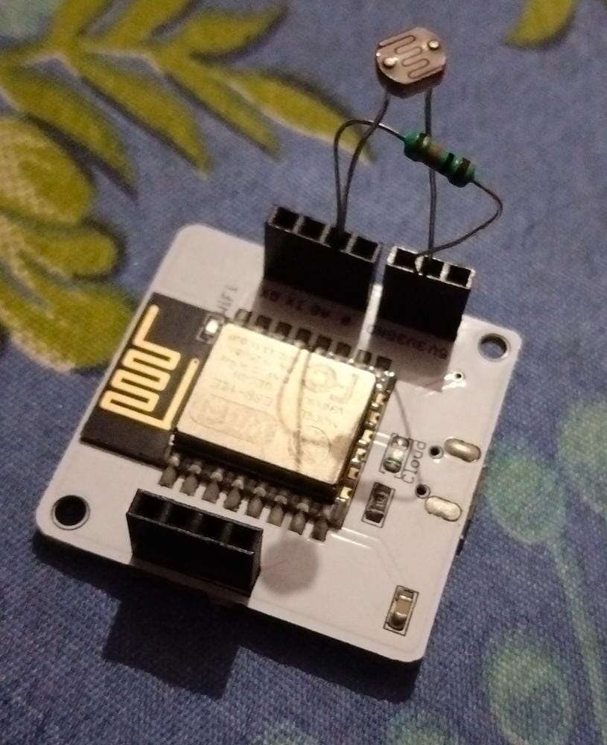

## 

## 

## **Software Programming**

We use JavaScript as the programming language for monitoring in this project.

Add this line of code in your program file:

plotChart(“time_stamp”,”light”);

Here, “light” is the variable name of AO Analog.

## **Output Plot**

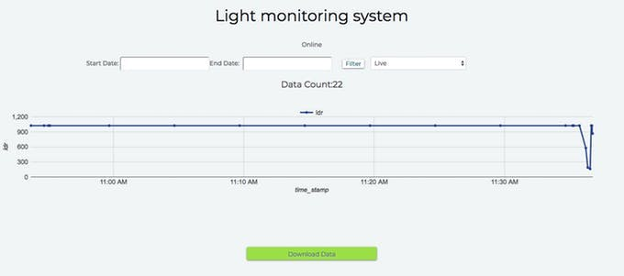

## **Conclusion/Outcomes**

So, now we know how to make our own Light Monitoring System.

This system can be used in our daily lives in many ways like as a Plant Monitoring system, maintaining light intensity in a room, etc. This is helpful for saving our time as well as the environment directly or indirectly.